**ASSIGNMENT-3**

**IAM ROLES**

**Done By**

**RANJITH KUMAR**

**Tasks To Be Performed:**

1. Create a role which only lets user1 and user2 from task 1 to have complete

access to VPCs and DynamoDB.

2. Login into user1 and shift to the role to test out the feature.

**TASK 1 :**

**STEP 1 :** Select IAM from aws services

**STEP 2 :** Under Access management select Roles

**STEP 3 :** Click Create Role

**STEP 4 :** In Select trusted entity page select “custom trust policy“

**STEP 5 :** Copy the ARN from the users and paste in the custom trust policy and click next .

**STEP 6 :** In Add permissions page select VPC and DynamoDB under permission policies and click next

**STEP 7 :** In Name, review, and create give the name of the role .

**STEP 8 :** Select create Role

**STEP 9 :** Role have been created

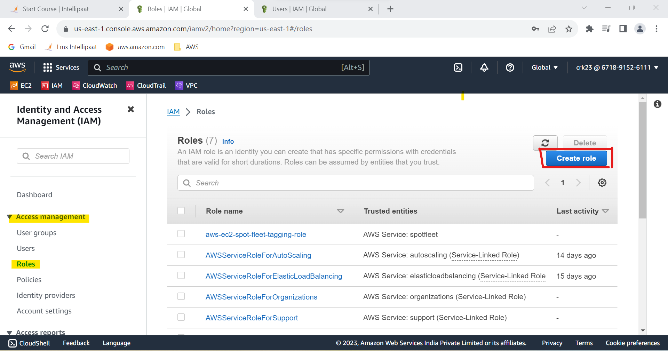

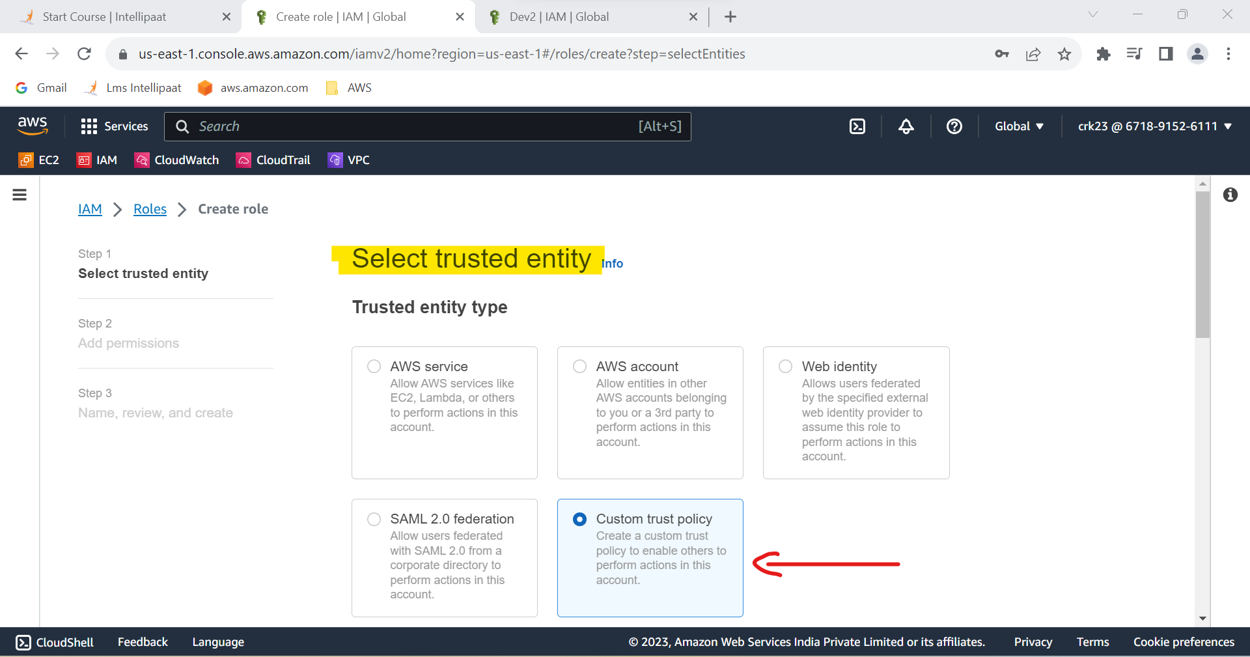

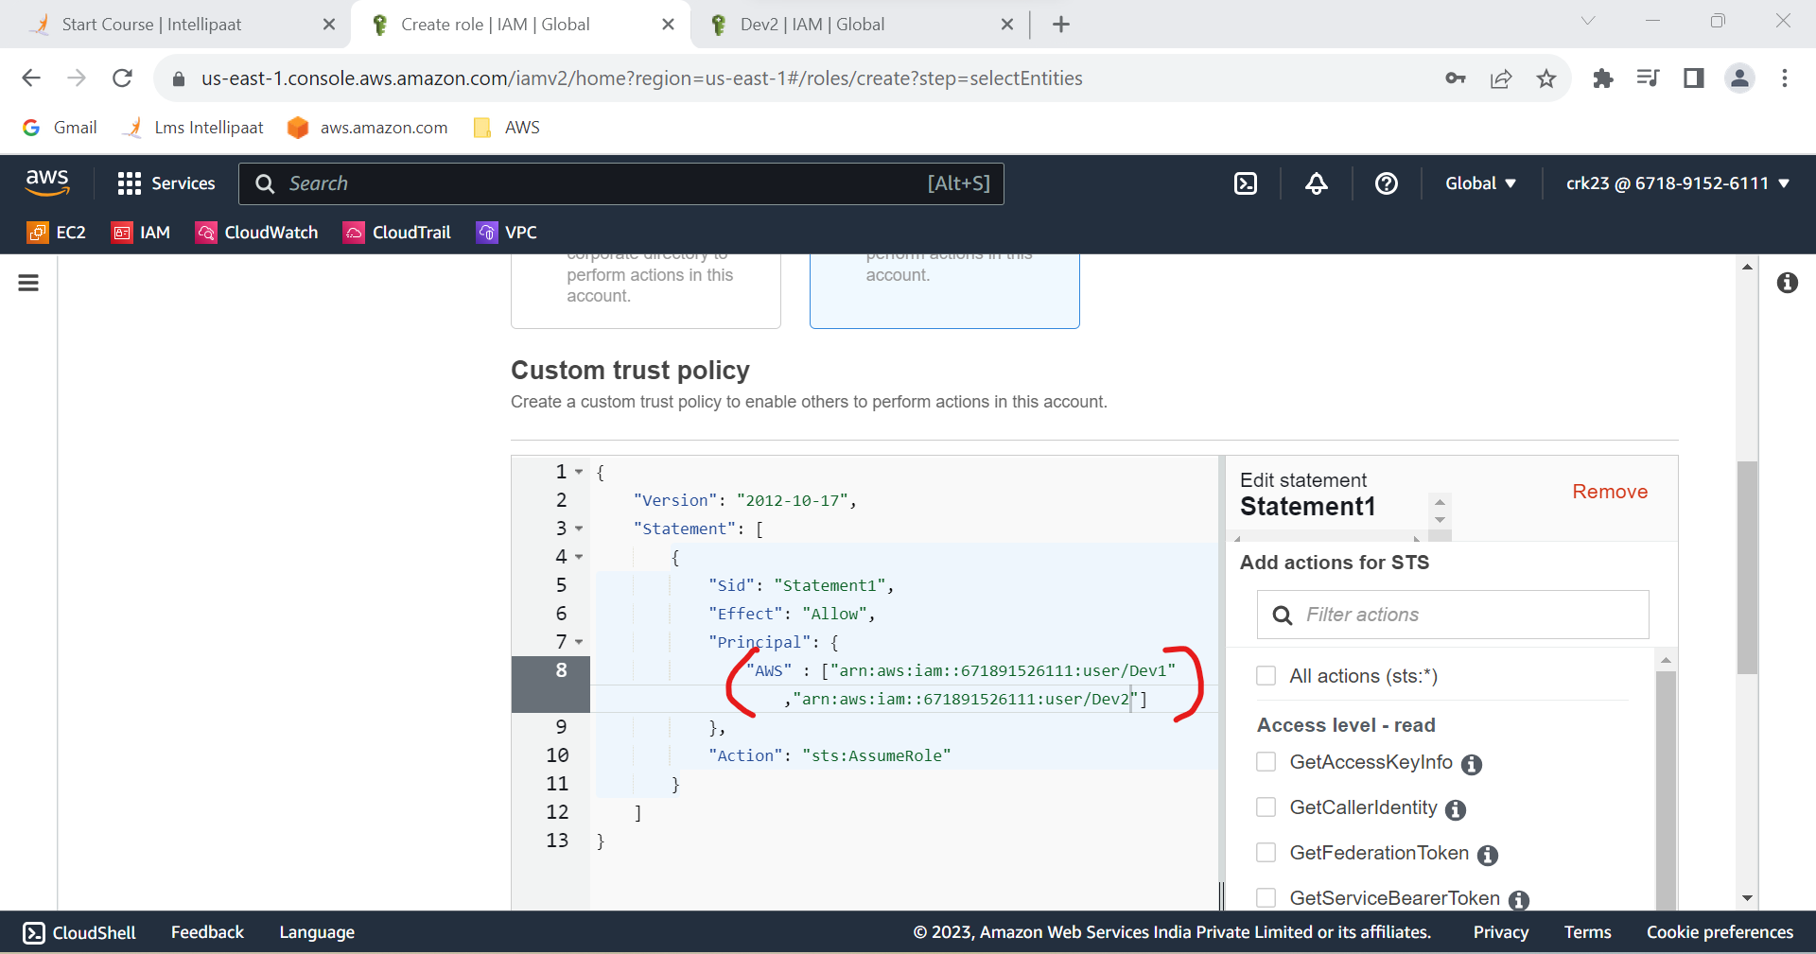

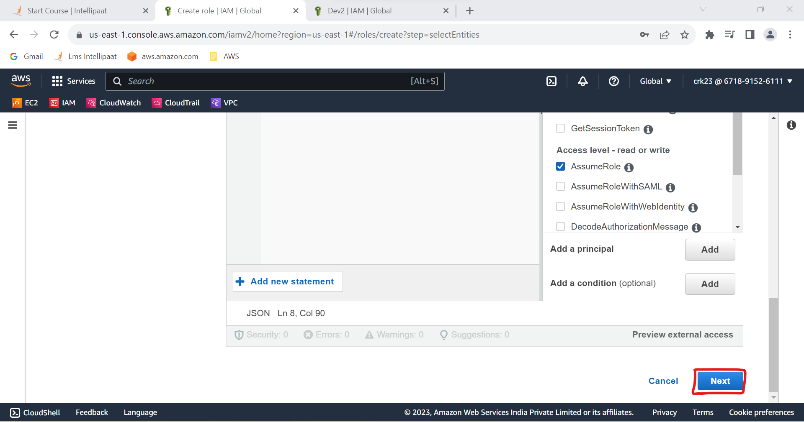

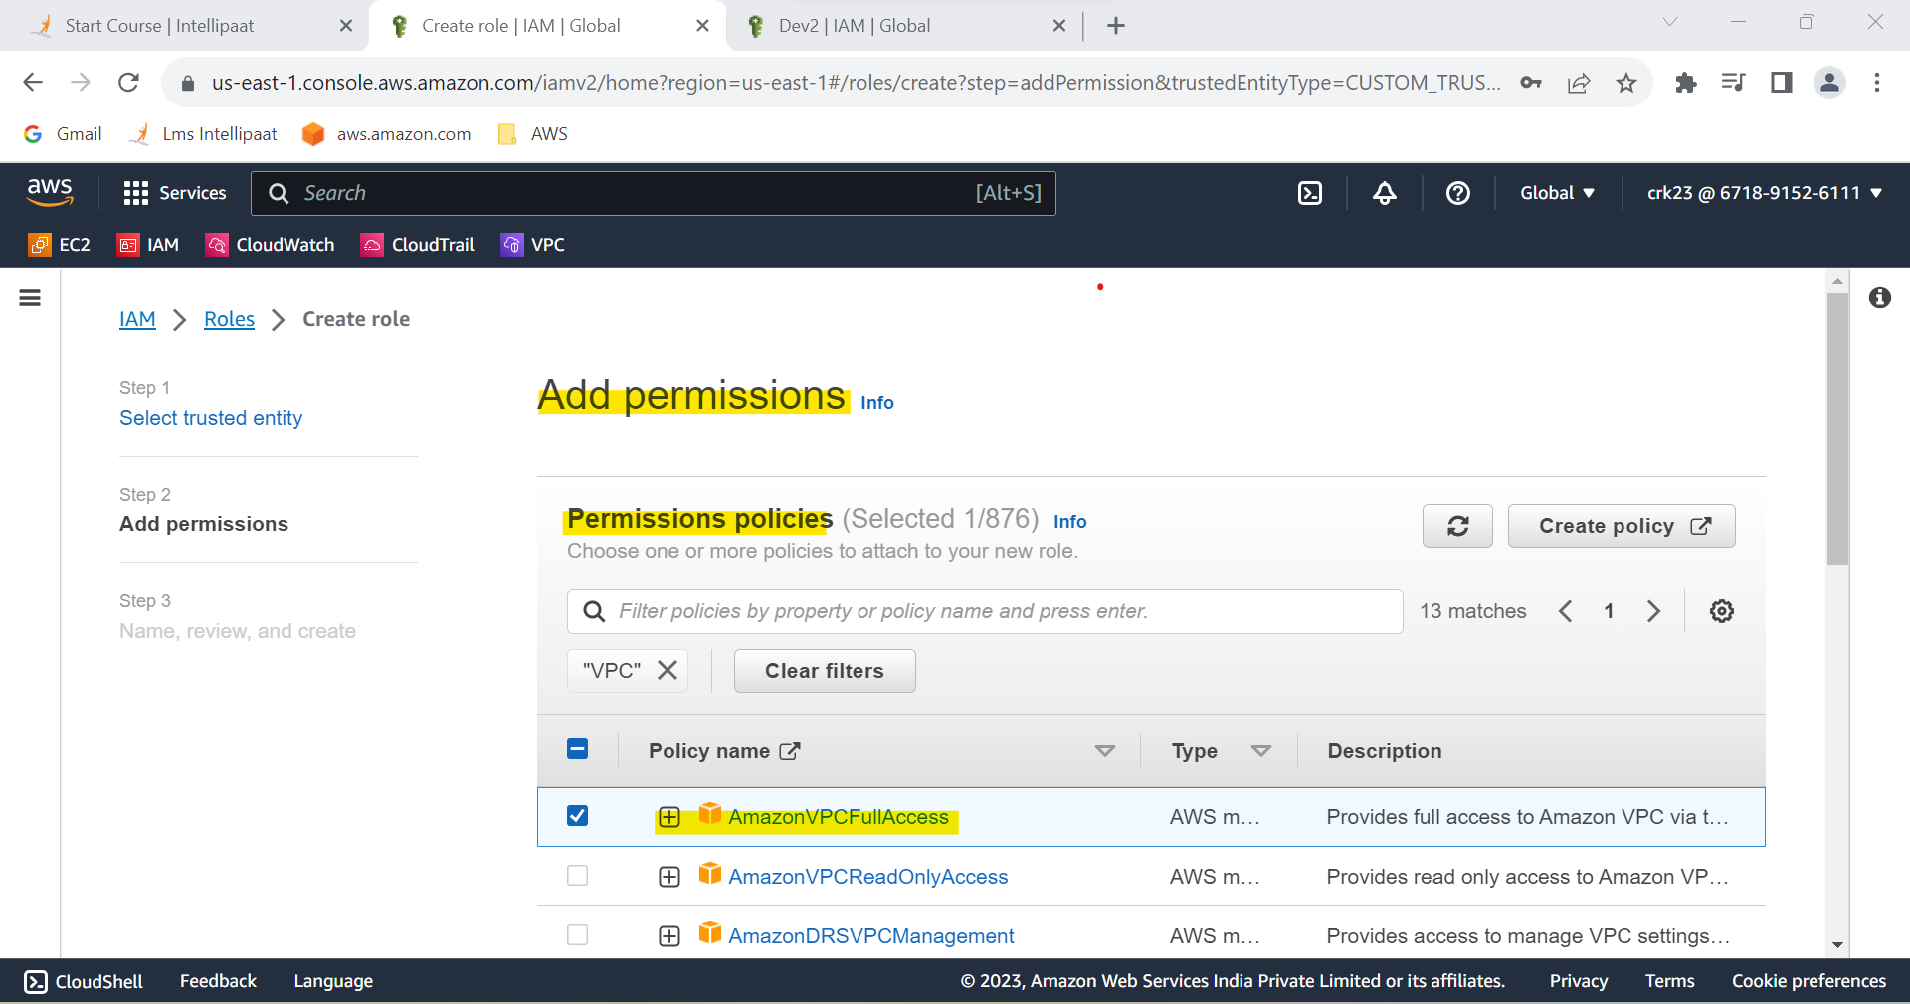

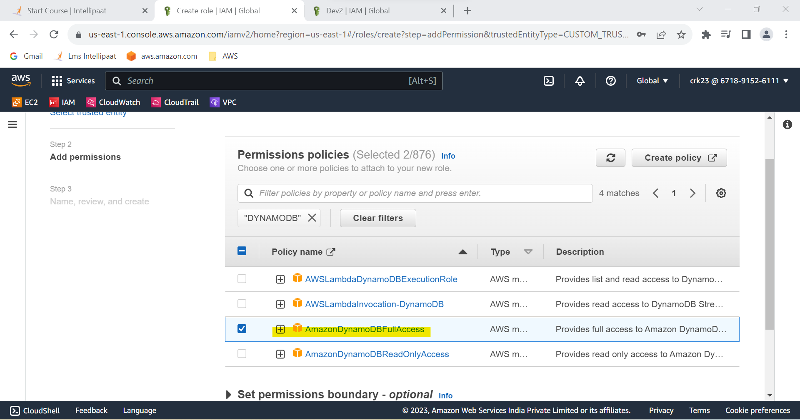

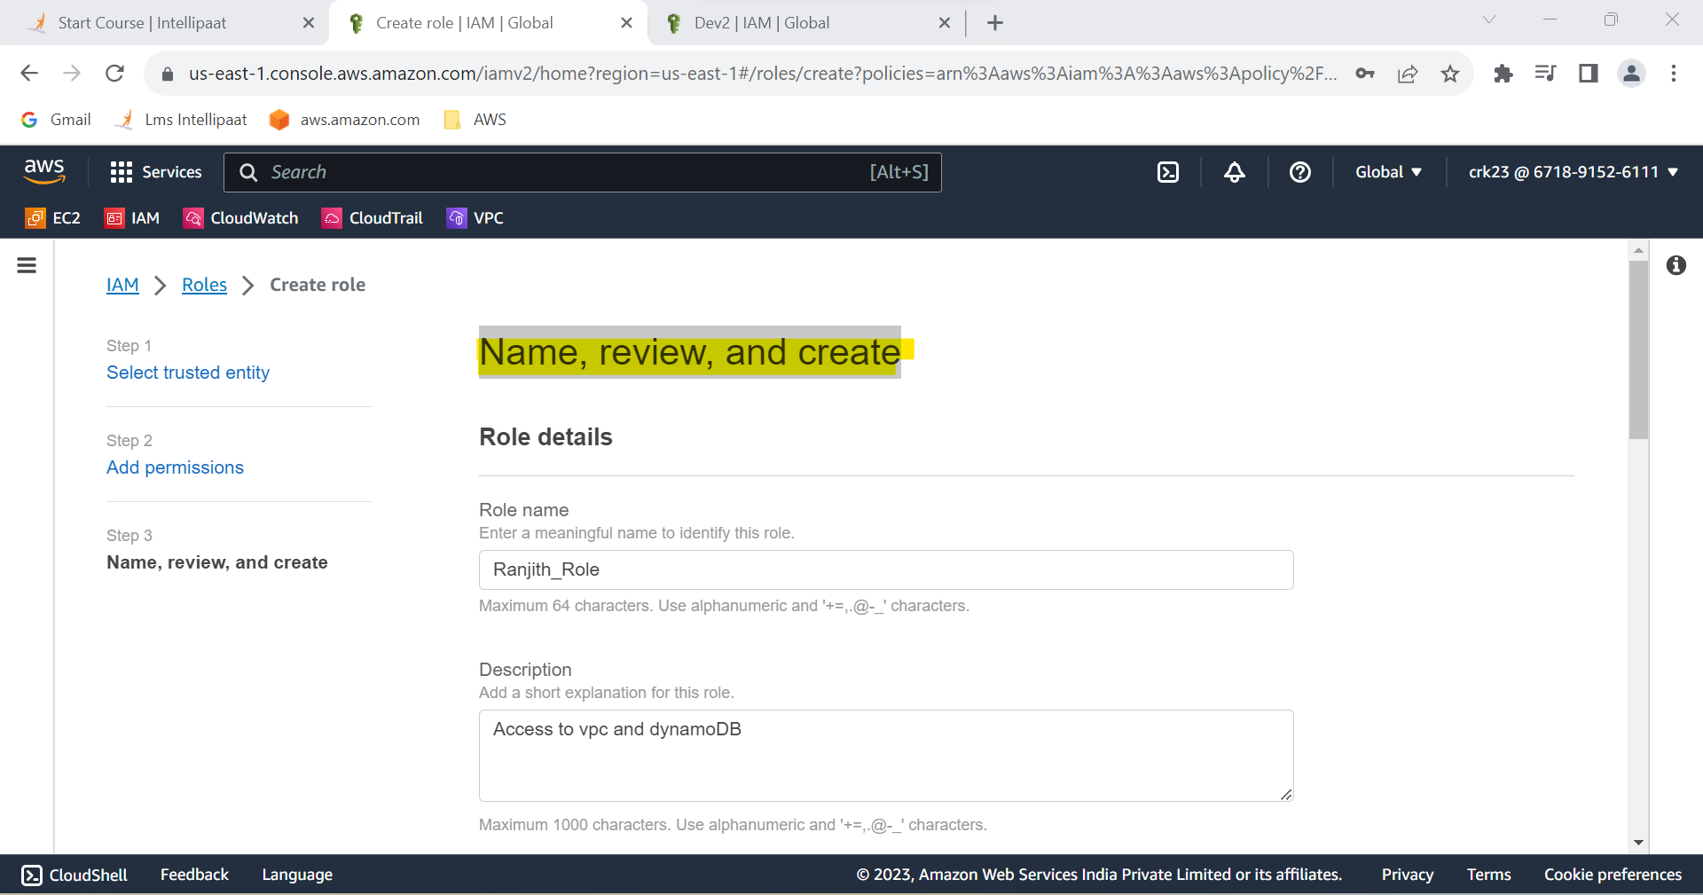

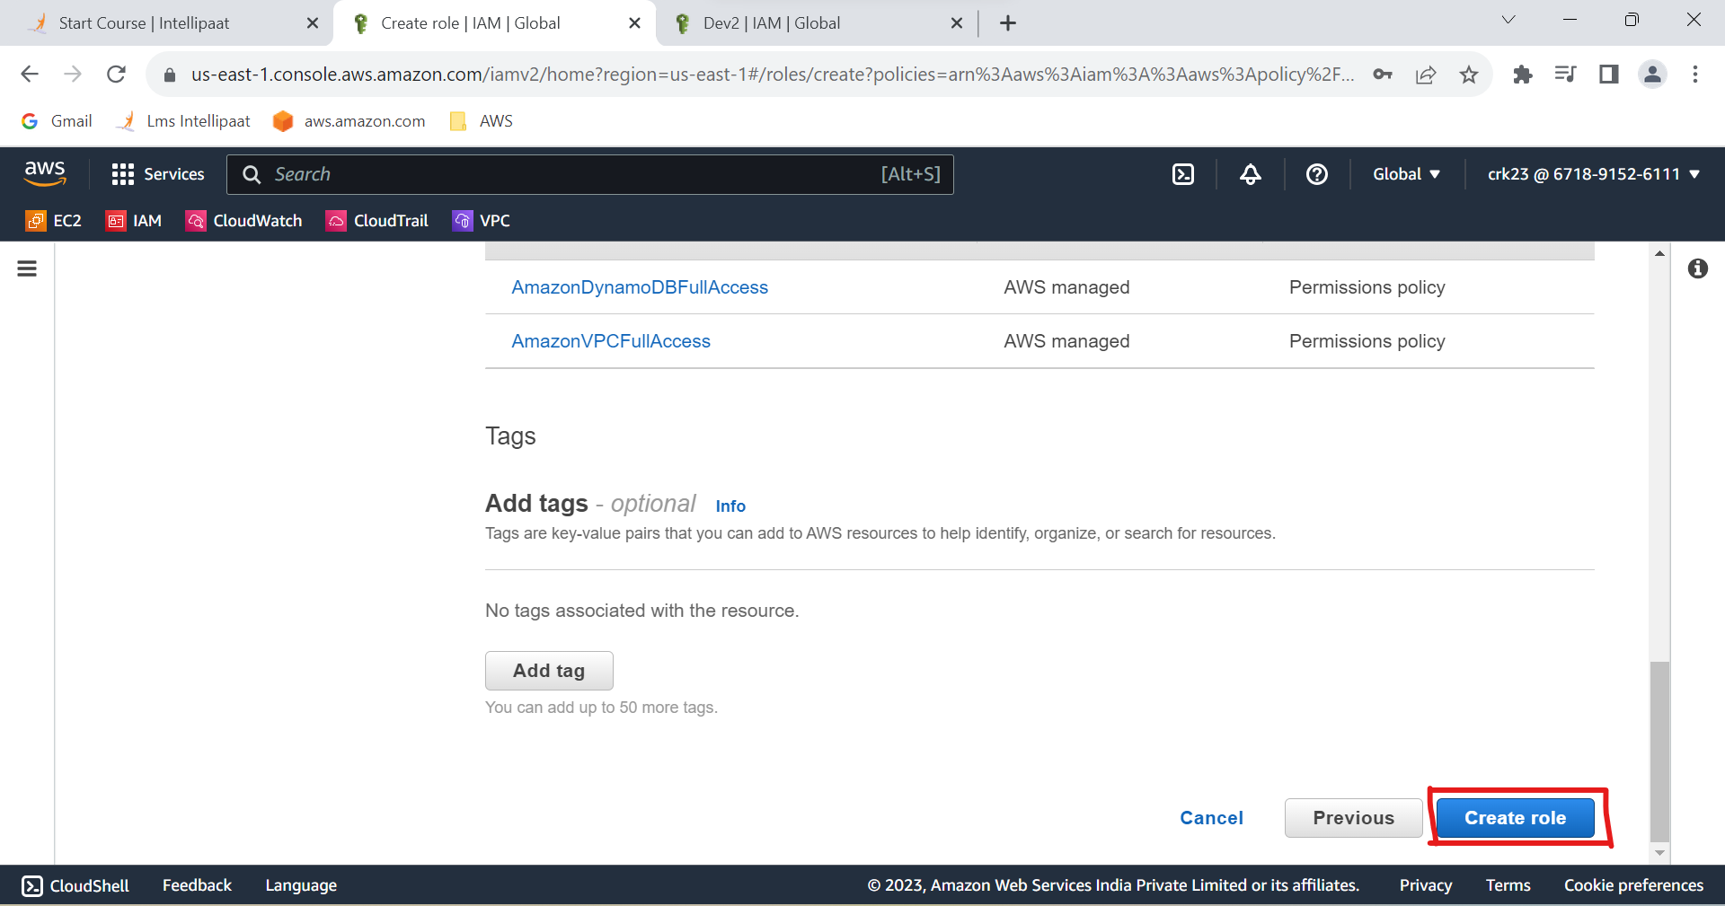

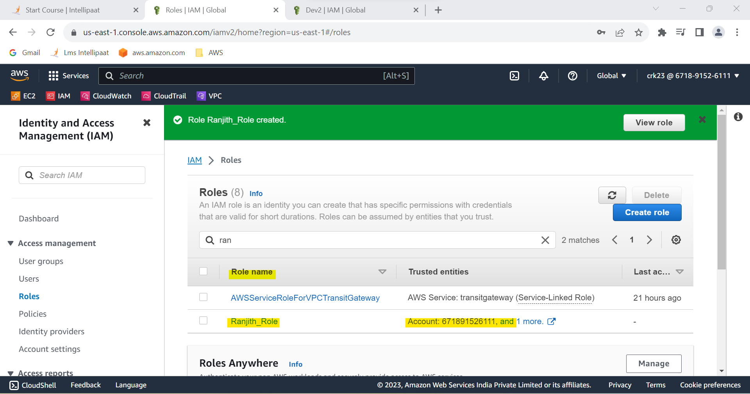

**TASK 1 OUTPUT :**

Created a role which only lets user1 and user2 from task 1 to have complete access to VPCs and DynamoDB.

**TASK 2 :**

Login into user1 and shift to the role to test out the feature.

**STEP 1 :** Login to the User 1 (Dev1) in another browser(edge)

**STEP 2 :** In the top right select account information and click switch role

**STEP 3 :** Login with necessary information

**STEP 4 :** Role have now been switched

**STEP 5 :** VPC and DynamoDB are accessed from the Ranjith_Role

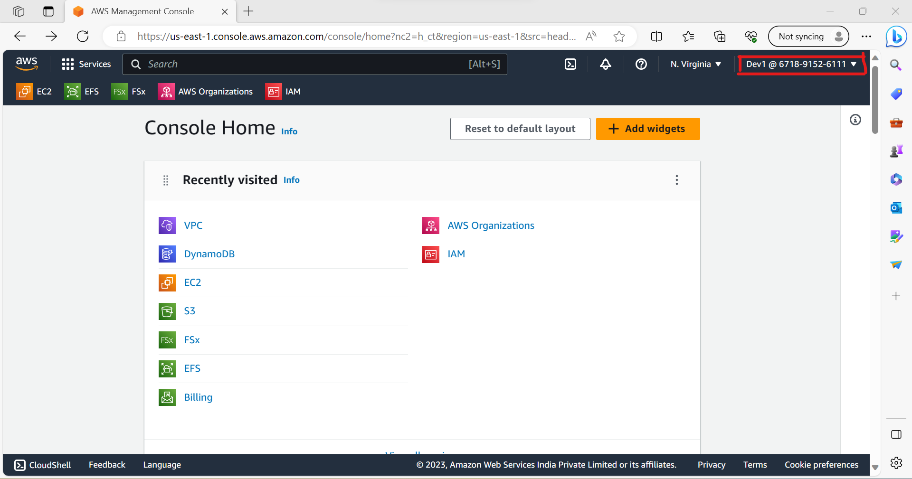

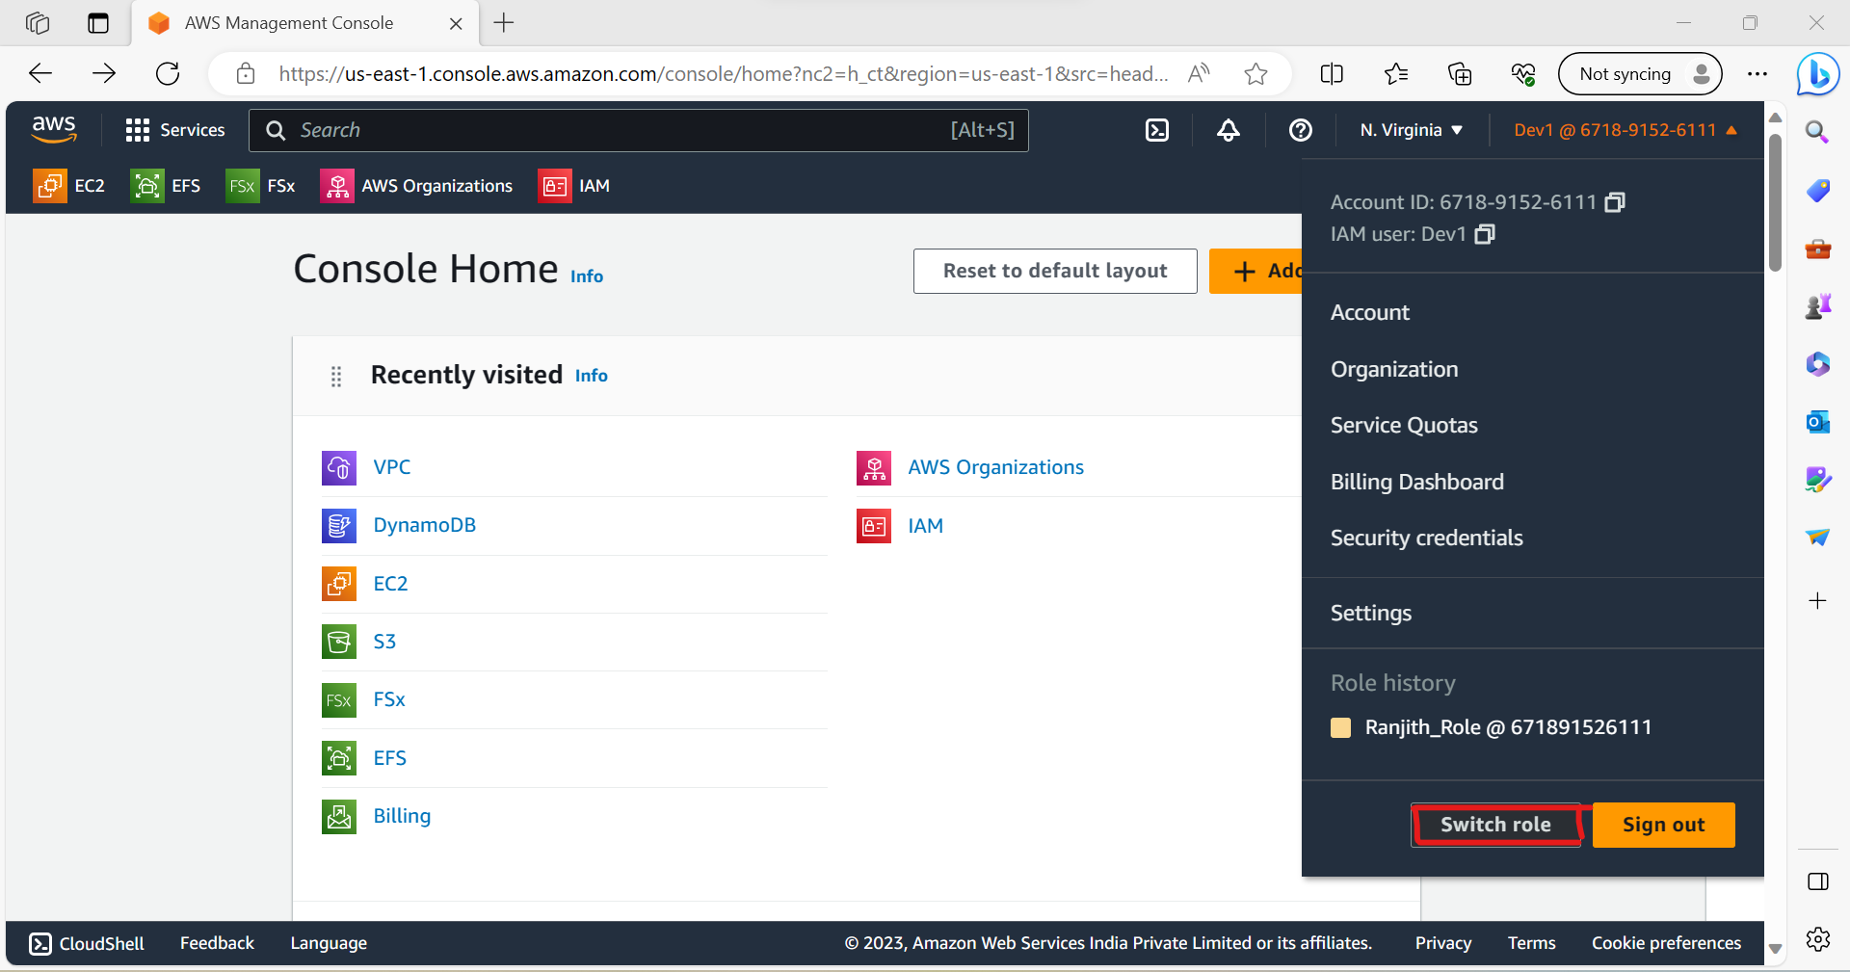

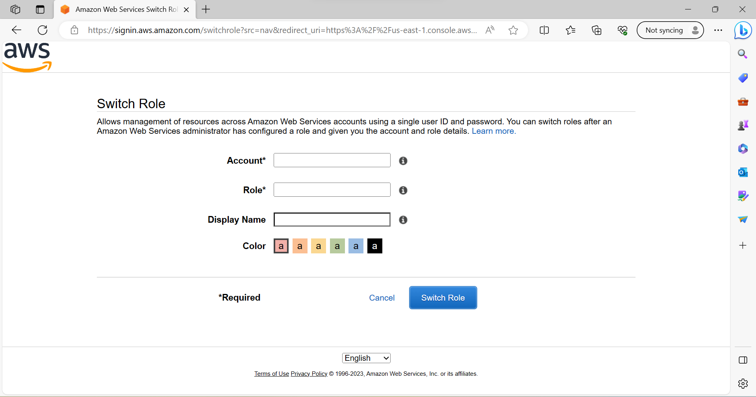

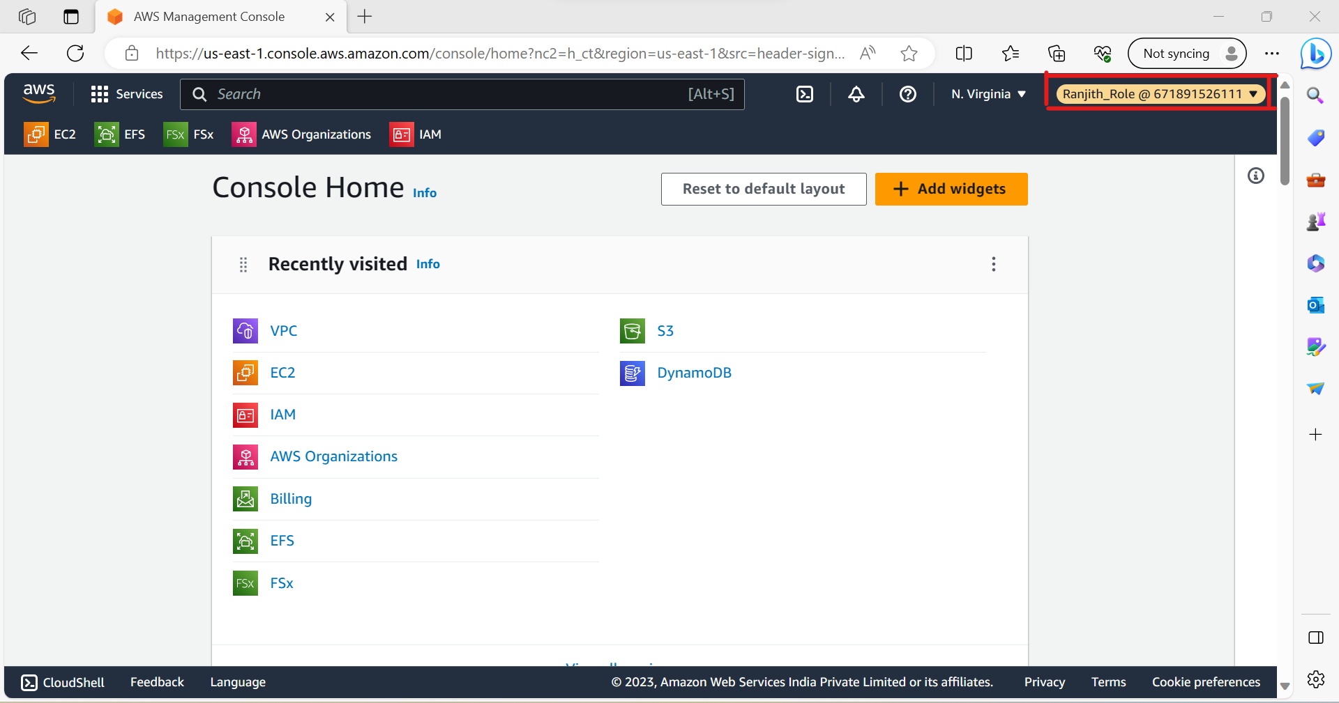

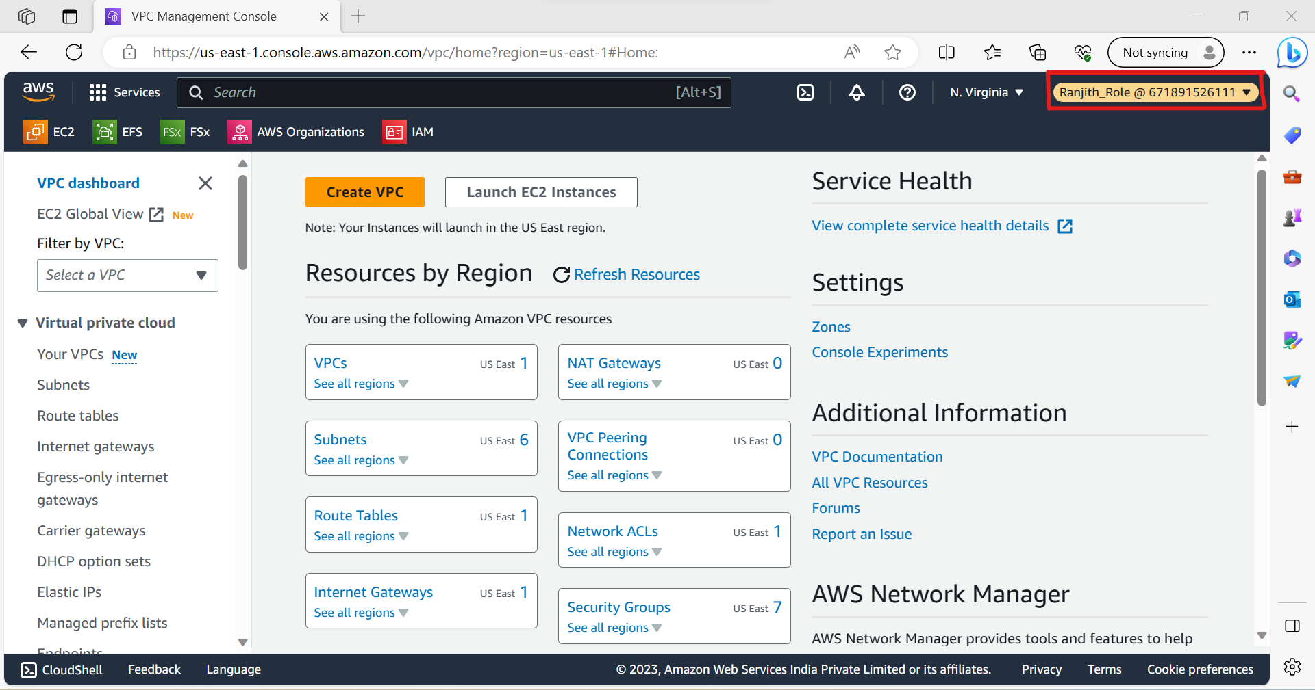

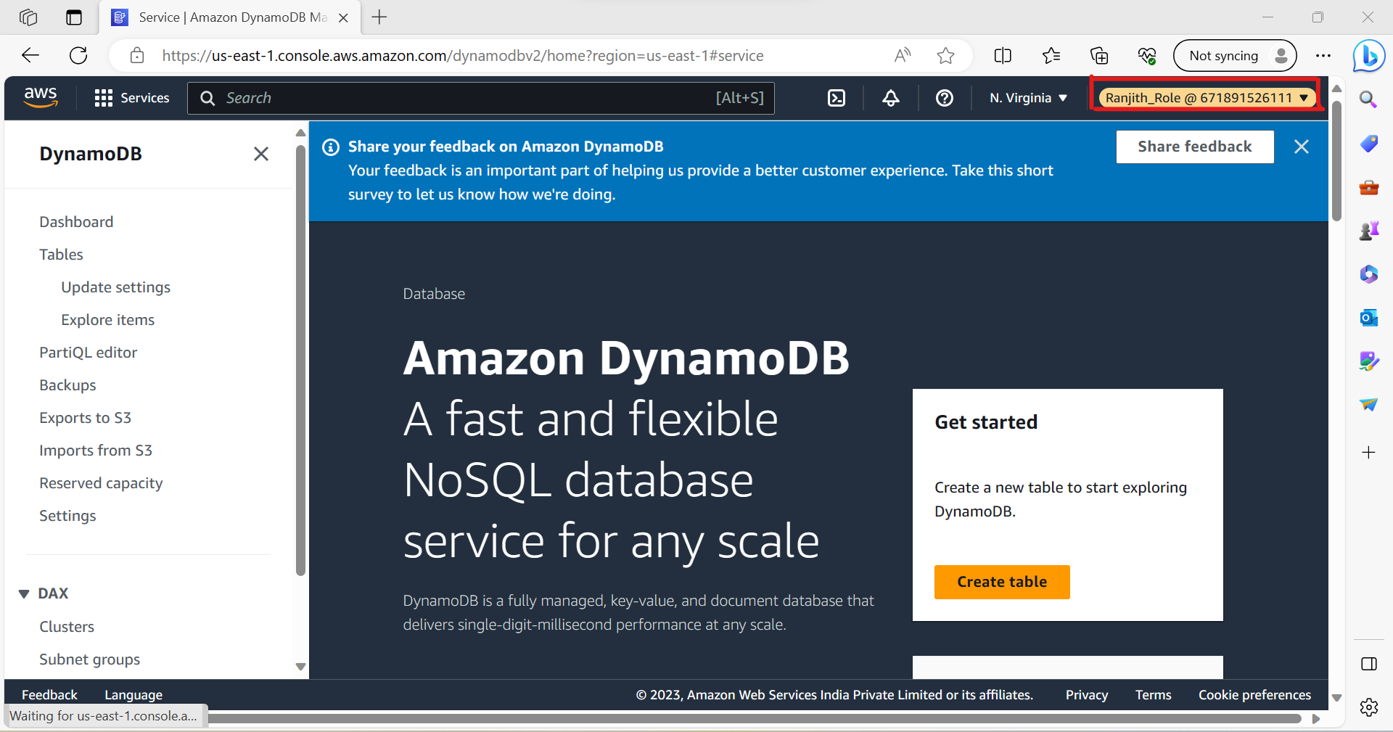

**TASK 2 OUTPUT :**

Logined into user1 and shift to the role to test out the feature.